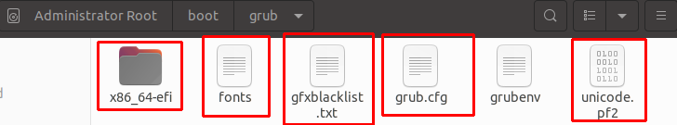

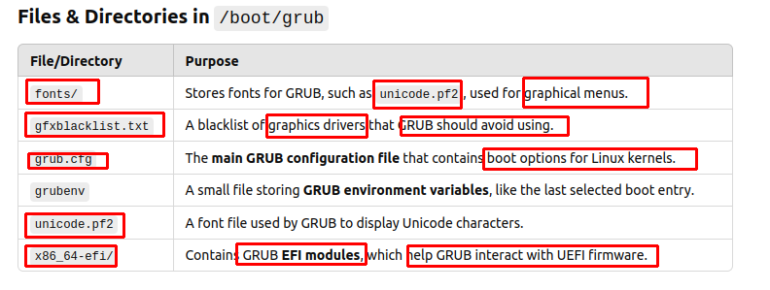
=======================================================================

In x86_64-efi → contain GRUB modules
At the start, GRUB (so small to contains all modules) loads necessary modules to boot the system:

